
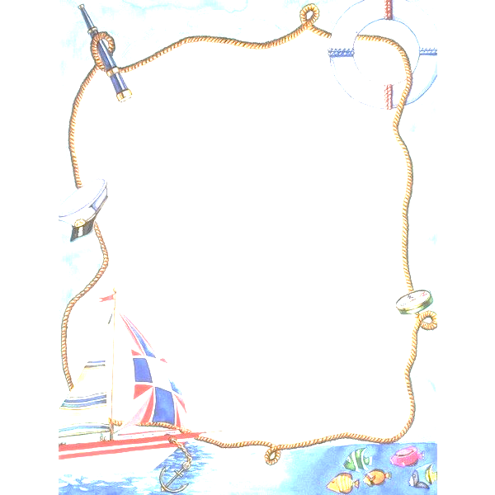
Travel around the world

- There are 15 hidden words
T | R | A | I | N | H | O | T | E | L | S | V
S | S | P | A | S | S | P | O | R | T | S | A
B | E | A | C | H | T | I | C | K | E | T | C
K | E | T | L | U | G | G | A | G | E | O | A
G | E | F | L | I | G | H | T | S | G | U | T
S | U | I | T | C | A | S | E | V | U | R | I
M | U | U | B | I | T | T | T | T | I | I | O
U | A | U | U | T | T | T | T | D | D | S | N
U | U | P | S | Y | B | I | T | E | E | T | A

- Match
1 | Забронировать номер в отеле | A. To go sightseeing
2 | Купить билет на самолёт | B. To pack a suitcase
3 | Собрать чемодан | C. To book a hotel room
4 | Осматривать достопримечательности | D. To buy a plane ticket
5 | Получить визу | E. To take photos
6 | Сделать фотографии | F. To get a visa
7 | Путешествовать на поезде | G. To travel by train
8 | Искать багаж | H. To look for luggage
9 | Заблудиться в городе | I. To enjoy a vacation
10 | Наслаждаться отпуском | J. To get lost in the city

- Virtual tour
You are a guide. Record an audio tour of Komsomolsk-on-Amur. Tell about the sights, history, culture.Коллаж «Карта мира»
- Collage "World Map"

Make a collage or map with images of countries you would like to visit. Include a brief description of each country in English (3-5 sentences).Игра-путешествие

- * A game of travel
Design a board game in English where players travel around the world answering questions and completing tasks.

