
Let's go on a guided tour
- There are hidden words that will help you create a route
t | t | a | k | e | t | h | e | b | u | s | a | v | c | a
s | u | b | e | h | t | f | f | o | t | e | g | i | o | j
m | r | r | o | v | d | z | z | g | u | r | n | m | l | k
a | n | o | n | t | h | e | l | e | f | t | c | n | b | f
v | t | n | t | t | e | d | f | a | v | n | f | m | v | i
b | o | n | h | m | o | g | d | f | e | r | w | q | b | n
m | t | y | e | h | f | t | w | g | h | b | n | r | f | t
t | h | e | c | n | g | w | h | q | f | g | n | e | u | h
v | e | c | o | r | d | g | n | e | u | s | t | z | q | e
w | l | e | r | o | n | t | h | e | r | i | g | h | t | t
b | e | v | n | y | h | j | k | m | s | i | s | h | f | e
r | f | b | e | q | w | f | g | p | y | h | g | k | j | e
m | t | y | r | e | r | w | p | g | y | i | l | h | u | r
w | e | q | f | v | b | o | y | n | a | m | e | m | t | t
v | b | g | h | n | m | e | q | r | o | c | r | o | s | s
v | q | w | e | r | t | y | t | u | i | o | p | a | s | d
d | f | g | h | j | k | s | l | z | x | c | v | b | m | s
q | w | e | r | t | o | y | u | i | o | p | a | d | f | g
h | j | k | l | g | z | x | c | v | b | n | m | f | b | c

- Поверните налево
- Поверните направо
- Сядьте в автобус
- Напротив
- Выйти из автобуса
- Перейти
- На улице
- Идти прямо
- Слева
- Справа
- На углу
Walk around our town
2. Your relatives have come to visit you. Draw a route map to 4 attractions in our city

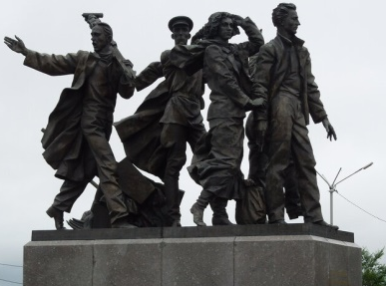
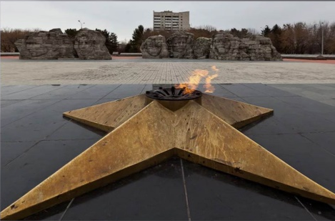
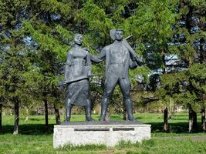
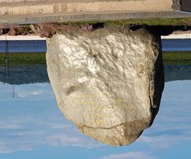
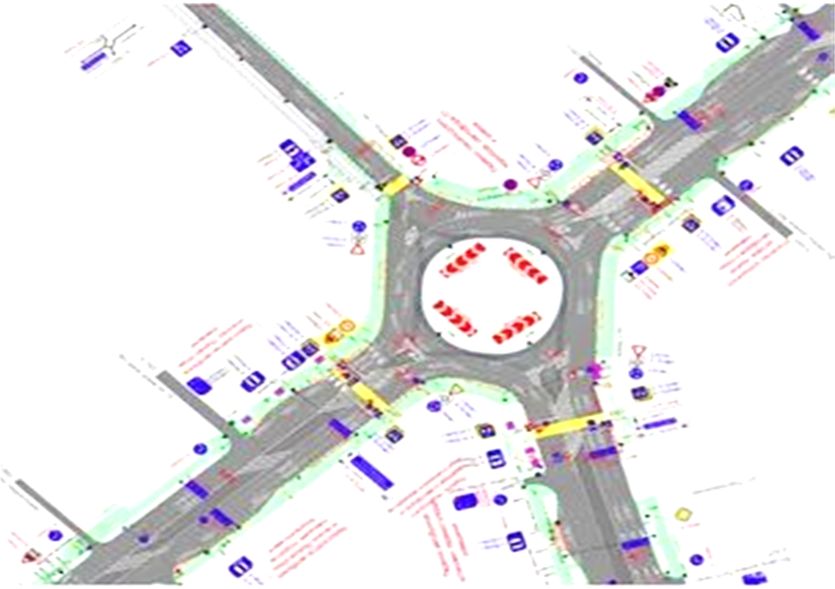

- Describe your route. Use the found words

----------------------------------------------------------------------------------------------------------------------------------------------------------------------------------------------------------------------------------------------------------------------------------------------------------------------------------------------------------------------------------------------------------------------------------------------------------------------------------------------------------------------------------------------------------------------------------------------------------------------------------------------------------------------------------------------------------------------------------------------------------------------------------------------------------------------------------------------------------------------------------------------------------------------------------------------------------------------------------------------------------------

