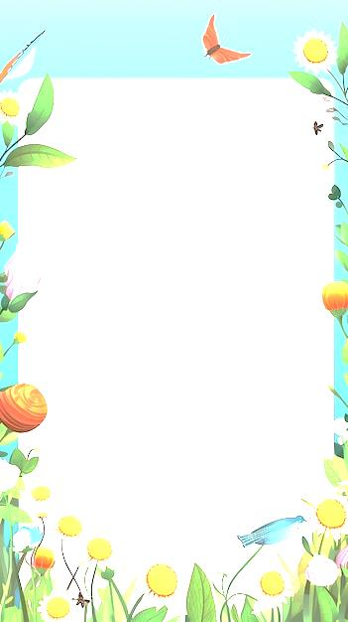

Рабочий лист по английскому языку для 6 класса (Spotlight)
Тема: «Как я провёл лето»

1. Выберите правильную форму:
Last summer I ___ to Sochi (go/went/gone).
She ___ local food already (try/tried/has tried).
At 5 p.m. yesterday, we ___ in the forest (walk/walked/were walking).
They ___ in a hotel for a week (stay/stayed/have stayed).
I ___ my friends yesterday (meet/met/have met).

2. Прочитайте текст «Как я провёл лето» , отметьте верные утверждения:
Last summer I had an unforgettable holiday. My family and I decided to go to Sochi, a beautiful city by the Black Sea. We booked a comfortable hotel with a great view of the sea. The weather was perfect: sunny and warm every day. In the mornings, I usually woke up early and went for a swim in the clear water. After that, we had breakfast in a cozy café near the beach. I tried many local dishes, and they were all delicious.
In the afternoon, we often went sightseeing. We visited the famous Olympic Park and took lots of photos. One day, we went to the Sochi Aquarium, where I saw many exotic fish and sea creatures. I was really impressed by the dolphin show! We also walked along the embankment and bought souvenirs in small shops. Sometimes we rented bikes and rode through the park, enjoying the fresh air and beautiful nature.
In the evenings, we usually returned to the hotel, had dinner, and walked along the beach. I liked to watch the sunset and listen to the sound of the waves. Once we went on an excursion to the mountains. The view from the top was breathtaking! I took many pictures there.
I met a lot of interesting people during my holiday. Some of them were from other cities in Russia, and we became friends. We played beach volleyball, went for walks, and shared our travel stories. I also improved my English because I talked to some foreign tourists.
This summer was full of adventures and new impressions. I learned a lot about Russian culture and traditions. I brought home not only souvenirs but also wonderful memories. Now I can’t wait for the next summer to come! I hope we will travel somewhere new and have even more fun.

- The family stayed in a small hotel.
- The boy swam in the sea every morning.
- They didn’t visit any museums.
- The food was tasty.
- He didn’t take any photos.
- They went to the mountains once.
- He met only Russian tourists.
- He didn’t try local food.
- The weather was rainy all the time.
- He hopes to travel next summer.

3. «A Letter to a Friend» — письмо другу

Напиши письмо другу на английском, рассказывая, как ты провёл лето. Не забудь про приветствие, основную часть и прощание.

4. «Summer in Pictures» — фотоколлаж с подписями

Собери 5–7 фотографий, иллюстрирующих твоё лето. Под каждой фотографией напиши по одному предложению на английском, описывающему, что происходит.

